My Target: : ____ / or ______ %



**Name: __ Teacher:**

|  |  |  |
| --- | --- | --- |
| Total marks  **/10** | **%** | **Weight**  **5%** |
|  |  |  |

Yr 8 Humanites & Social Sciences:

*Civics & Citizenship*

***Task 9*- Museum Display**

**In-Class Graphic Organiser Validation: PART 1**

1. In your Museum Display assessment you had to research an example of an individual or group taking direct action by methods such as public demonstrations or social media campaign. Use the examples and explanations of each graphic organiser to help you choose what graphic organiser would be used to display the following:

* What caused the protest?
* The events that followed.
* The end result of the direct action.

**Number** each graphic organiser below in order of most **useful** to **least useful**: one being most useful and four least useful.

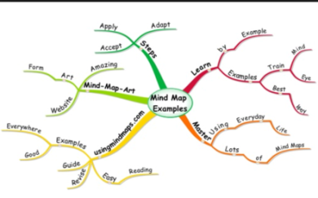

**Brainstorm**

A brainstorm is a graphic organiser that shows a central idea with its corresponding characteristics

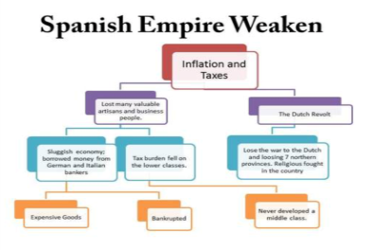**Flow Chart**

A flow diagram or sequence chart shows a series of steps or events in the order in which they take place. Any concept that has a distinct order can be displayed in this type of organizer. A flow chart is excellent for showing the steps necessary to reach a final point.

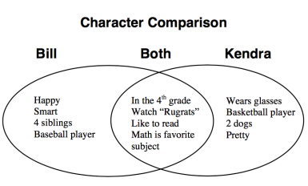

**Venn Diagram**

A compare/contrast or Venn diagram is used to identify the similarities and differences between two or more concepts.

**Hierarchy Pyramid**

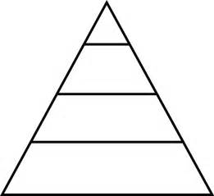

List from highest to lowest of importance or a visual

representation displaying proportional value.

1. **Justify** your choice of most useful graphic organiser. A good answer will use full sentences.

(2 marks)

1. **Explain** how the public demonstration/social media campaign that you studied is an example of democracy in action.

(4 marks)

**END OF PART 1**